Platform and Ecosystem Strategy Accelerates Digital Transformation:
197 Fortune Global 500 Companies Tap Huawei for Success in New ICT Era

[Shanghai, China, September 5, 2017] Huawei, and its Fortune Global 500 partners and customers showcased jointly-developed ICT solutions driving digital transformation at HUAWEI CONNECT 2017, which kicked off today in Shanghai. Huawei also unveiled its “Platform + Connection + Ecosystem” strategy designed to promote development of an enterprise-level Internet of Things (IoT).

Enterprises are increasingly focused on digital transformation as a competitive advantage and many Fortune Global 500 companies across a wide range of industries are at the tipping point of this transition. Their challenge is to develop new business models that increase Connection and engagement. What’s needed is a digital transformation platform that connects intelligence, data, and devices, enabling them to increase engagement with partners and develop applications that foster innovation.

"Huawei is working with customers and partners to develop innovative, differentiating and leading solutions, and create an open, flexible, secure and agile platform for enterprises to achieve digital transformation,” said Diana Yuan, President of Marketing and Solution Sales for Huawei’s Enterprise Business Group. “As an innovation-oriented company, Huawei is also speeding up implementation of its own digitization strategy and will share its transformation best practices with the industry. Huawei Enterprise Business Group’s capabilities are steadily growing and helping customers gain a competitive advantage and achieve business success through digital transformation. To date, 197 companies on the Fortune Global 500 list and 45 of the top 100 enterprises have chosen Huawei as their partner for digital transformation, a testimony to the strength of our strategy and solutions."
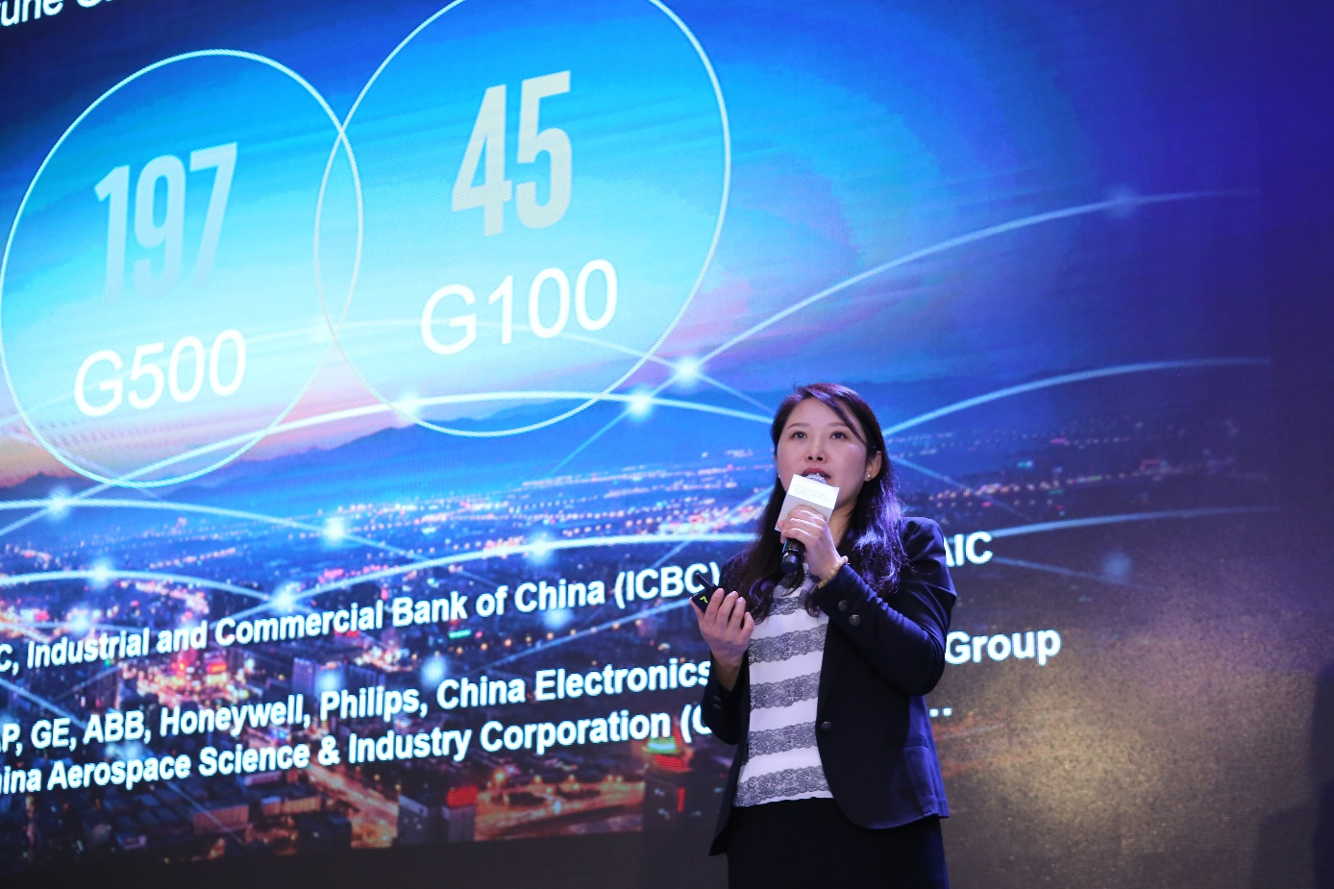
Diana Yuan, President of Marketing and Solution Sales for Huawei’s Enterprise Business Group

In the future, digitalized companies will be built around data generation, transmission and processing. Huawei has a comprehensive portfolio of products and solutions to enable this development in enterprises across diverse industries, including networking, computing, storage, data center infrastructure, Big Data, hybrid cloud and IoT platforms. Huawei also provides leading new ICT and an ecosystem of leading partners to deliver industry-specific applications such as video cloud for the public safety sector, Big Data for the financial services industry, and IoT platforms for power companies.

This year, Huawei released a series of industry-leading products, such as OceanStor Dorado V3, a new-generation all-flash storage system, and FusionServer V5, the latest generation of the FusionServer series.
IDC reported that Huawei's data center switches ranked first in market share in China in 2016. In a recent report, Gartner stated that in Q1 of 2017, Huawei’s sales revenue, number of shipments and delivery capacity were all ranked first in China’s server market. Gartner also highlighted that Huawei’s horizontal solutions including data centers, campus networks and IoT platforms have multiple network connections and all-scenario coverage, and offer stability and security.

At HUAWEI CONNECT 2017, Huawei will enhance its broad portfolio with the launch of FusionBridge, a hybrid cloud solution; FusionCloud Stack, a public cloud solution; Atlas, a new-generation smart cloud hardware platform; Intelligent Connections, a new network architecture; and a new generation of SD-WAN solutions.

Huawei is also using the Shanghai event to provide a complete overview of its enterprise-level IoT solutions designed to accelerate Connection. The solutions include: the Huawei OceanConnect IoT platform, a one-stop IoT service platform for enterprises; a comprehensive access solution that integrates enterprise broadband and narrowband networks and utilizes licensed and unlicensed spectrums; the Edge-Computing-IoT (EC-IoT) solution with cloud-device integration; and all-rounded safety capabilities applicable to chipsets and platforms.

Huawei helps customers rapidly develop and deploy business applications through its “Platform + Connection + Ecosystem” strategy, which delivers an open and mutually beneficial ecosystem, a platform that allows flexible deployment, and full-series, full-scenario, and modular connections. Huawei’s enterprise-level IoT solutions have been adopted in many areas, including smart cities, IoT for elevators, smart buildings, and the sharing economy.

Huawei has become a digital transformation facilitator working with its global partners to provide best practices and innovative ICT solutions that help companies around the world embrace digital transformation and drive business success. Recent successes include:

Huawei partners with Dubai Airports to build prefabricated modular data center with Tier III certificates from the Uptime Institute for both design and construction. The data center will carry services that cover almost every aspect of the airport, including flight information and airport operations, passenger transport and baggage services, video surveillance and more. By providing ICT solutions that are agile, rapidly deployable, reliable, energy-efficient and easily maintained, Huawei provides powerful support to carry out highly efficient business operations in Dubai Airports.

Rob Newman, Head of Programme Management, Technology & Infrastructure, Dubai Airports, said: "The utilization of leading ICT is key in promoting business growth, speeding innovation and enhancing the customer experience within Dubai International Airport. We will strive to further improve the reliability of the airport’s system and reduce operational costs."

Buildings are becoming more intelligent due to the interoperability between smart building systems and information systems achieved through the adoption of IoT, cloud computing and Big Data. Huawei and Honeywell are collaborating on the development of smart campus solutions for educational institutions, enterprises, commercial buildings, branch online shops, industrial premises and more.
Commenting on the collaboration, Stephen Hu, Marketing Director of Honeywell Building Solutions, Honeywell Home & Building Technologies Greater China, said: "Huawei and Honeywell announced that we will jointly launch smart building solutions across the globe in March 2017. Since then, we have been working together on smart city projects to help city operators build green, safe and efficient urban infrastructures, reduce urban management cost, and provide better living environments for the people."

An increasing number of industry-leading enterprises around the world have chosen Huawei as their partner in digital transformation. For example, Huawei’s innovative products have increased the production efficiency of more than 1,000 manufacturing enterprises. Its solutions for the financial industry, which are based on an open architecture, have accelerated business innovation in more than 300 financial institutions. Huawei’s smart-grid solutions have optimized the power transmission and distribution businesses of 170 power companies. In addition, Huawei’s IoT solutions have saved operational costs for more than 100 logistics companies.

In a fast-changing digital world, Huawei is committed to understanding the needs of its customers and creating a mutually beneficial ecosystem with its partners to help customers drive successful digital transformation.

HUAWEI CONNECT, Huawei's flagship event for the global ICT industry, is taking place at the Shanghai New International Expo Centre (SNIEC) from September 5-7, 2017 with the theme “Grow with the Cloud”. At this global platform for open collaboration, Huawei together with its customers and partners will explore new growth opportunities through digital transformation. For more information, please visit http://www.huawei.com/en/events/huaweiconnect2017/.

-Ends-

About Huawei
Huawei is a leading global information and communications technology (ICT) solutions provider. Our aim is to enrich life and improve efficiency through a better-connected world, acting as a responsible corporate citizen, innovative enabler for the information society, and collaborative contributor to the industry. Driven by customer-centric innovation and open partnerships, Huawei has established an end-to-end ICT solutions portfolio that gives customers competitive advantages in telecom and enterprise networks, devices, and cloud computing. Huawei's 180,000 employees worldwide are committed to creating maximum value for telecom operators, enterprises, and consumers. Our innovative ICT solutions, products, and services are used in more than 170 countries and regions, serving over one-third of the world's population. Founded in 1987, Huawei is a private company fully owned by its employees.

For more information, please visit Huawei online at www.huawei.com or follow us on:
http://www.linkedin.com/company/Huawei
http://www.twitter.com/Huawei
http://www.facebook.com/Huawei
http://www.google.com/+Huawei
http://www.youtube.com/Huawei

