Huawei Launches the First All-Cloud, Network-wide Smart Video Cloud Solution
Driving the Evolution of Videos to Enable Actionable Intelligence that Improves City Safety

[Shanghai, China, September 5, 2017,] At Huawei Connect 2017, Huawei today launched the industry's first all-cloud, network-wide smart video cloud solution, together with industry partners including Yitu, SenseTime, NetPosa, Harzone, MIMOS, and Qognify. The open cloud platform benefits from a vast ecosystem of partners delivering a wide-range of smart video analytic algorithms. This provides a strong computing engine that supports public safety video application services and accelerates video application innovation to help public safety organizations better serve and protect citizens.

As cities embrace digital transformation, video is becoming an important tool for public safety management and city governance. In China, over 60% of public safety cases are solved using video. However, social video systems and security video systems typically operate independently, which makes video and data sharing difficult. Cross-regional crimes are increasing and without a collaborative solution, obtaining and analyzing video feeds consumes a significant amount of time, manpower, and costs. There is a pressing need among public safety agencies to find more efficient and open video application capabilities to address these challenges.

Huawei’s Smart Video Cloud constructs "One City, One Cloud" concept

Kevin Bai (the fifth from left), General Manager of Government Solutions Department, Huawei Enterprise Business Group, and partners launched the Smart Video Cloud Solution.

Kevin Bai, General Manager of Government Solutions Department, Huawei Enterprise Business Group, said: "Huawei’s Smart Video Cloud is based on an open cloud platform, which supports algorithms and applications from many partners to enable effective video sharing. Network-wide distributed smart analysis significantly increases video analysis efficiency; and in cross-departmental and cross-regional cases, the solution can rapidly respond with analysis results. In addition, converged Big Data technologies can uncover hidden insights from videos to support the work of public safety agencies. The video cloud can also be used as a service for other organizations or institutions, for example to support traffic regulation, detect the crowd flow at scenic spots, locate missing people, and many other public services. This solution allows videos to play a disruptive role in public safety applications, evolving from purely surveillance to generating actionable intelligence which takes city safety to a new level."

In the past few years, China has experienced a breakthrough in video networking development, and thus promoting the construction of the video application ecosystem. Discussing Shenzhen's public safety management experience, Zhang Yong, Captain of Shenzhen's Public Security Bureau Video Surveillance Police Detachment, said: "Videos have played a key role in improving security for Shenzhen’s citizens. We have worked with Huawei for the past two years to develop a comprehensive video platform, which has helped us solve countless cases. Huawei’s video cloud, which combines centralized computing and edge computing capabilities, will help us further enhance our video application services to ensure peace in Shenzhen’s communities."

Huawei displays a variety of the latest C-C4ISR collaborative public safety solutions
At Huawei Connect 2017, under the theme of "New ICT, the Road to Collaborative Public Safety", Huawei displayed the latest C-C4ISR collaborative public safety solutions. Among them, many new solutions and applications were showcased for the first time:
- The Huawei Video Cloud Platform brought together 16 partners to demonstrate how a large-scale video application ecosystem enables a city council to distribute different tasks to different branch offices to perform video networking and smart analysis for dangerous object identification, crowd analysis, facial recognition at a far distance, and many other tasks. The demonstration showed how the platform strengthens the video application services of public safety customers.
- Applications from Vastio, Xinyi, MiningLamp, Zenith and other partners running on Huawei's Big Data platform create an information command and action-infused smart command center. Various usage scenarios were displayed, such as how to use Big Data and machine learning to predict risks, gain insight into the opinions in public media, and prevent and alleviate traffic congestion.
- An End-to-end digitized emergency response management solution helps public safety agencies efficiently manage natural or man-made emergencies and protect citizens.
- An all-in-one station with the industry’s highest level of integration increases deployment efficiency by 56%, and can achieve ubiquitous alarms, investigation, and monitoring coverage.
- iOMC, a one-stop full-lifecycle service platform with unified operations and maintenance (O&M) capabilities for safe cities, integrates the domain of every product, and performs unified monitoring and unified alarm dispatching based on the service scenario.

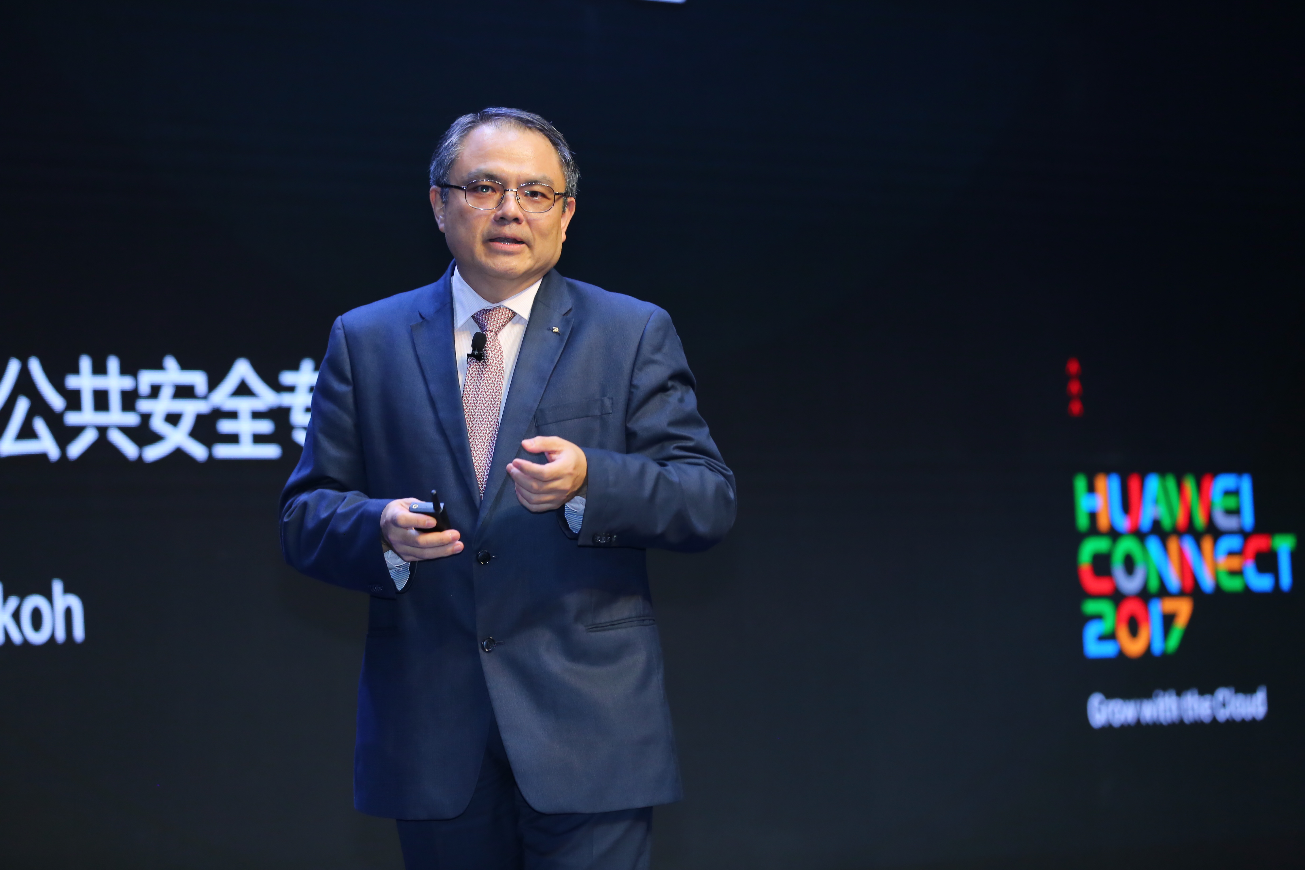
Hong-Eng Koh, Global Chief Public Safety Expert for Huawei Enterprise Business Group, explained collaborative public safety.

The digital transformation of the public safety industry will depend on the maturity of the applications market, and there will be greater demand for collaboration between these applications. For this reason, Huawei has taken the lead to introduce a public safety industry enablement platform at HUAWEI CONNECT 2017. The platform serves as a smart warehouse market where capabilities commonly used in the public safety industry, including a wide-range of video smart analysis capabilities in video cloud, integrated communications capabilities, IoT, and Big Data, are readily available for delivery. The user or software provider can use a "building-block" approach to select their required capability components, making it easy to develop new service applications quickly. The solution can empower the entire ecosystem and drive momentum in the journey to collaborative public safety, presenting new opportunities for ecosystem development to help partners achieve business success while growing with Huawei.

To date, 197 of the Fortune Global 500 companies and 45 of the top 100 enterprises have chosen Huawei as their partner for digital transformation. These companies are realizing the benefits of Huawei’s one-stop, innovative ICT infrastructure platform with cloud-pipe-device integration and open ecosystem for customers across various industries.

HUAWEI CONNECT, Huawei's flagship event for the global ICT industry, is taking place at the Shanghai New International Expo Centre (SNIEC) from September 5-7, 2017 under the theme of “Grow with the Cloud”. At this global platform for open collaboration, Huawei together with its customers and partners will explore new growth opportunities through digital transformation. For more information, please visit http://www.huawei.com/en/events/huaweiconnect2017/.

- End -

About Huawei
Huawei is a world-leading information and communications technology (ICT) solutions provider. Our aim is to build a better connected world, acting as a responsible corporate citizen, innovative enabler for the information society, and collaborative contributor to the industry. Driven by customer-centric innovation and open partnerships, Huawei has established an end-to-end solution advantages in the telecom networks, terminal, and cloud computing domains. Huawei's 180,000 employees worldwide are committed to creating maximum value for telecom operators, enterprises, and customers. Huawei's innovative ICT solutions, products, and services are used in more than 170 countries and regions, serving over one-third of the world's population. Founded in 1987, Huawei is a private company fully owned by its employees.

For more information, please visit Huawei online at www.huawei.com or follow us on:
http://www.linkedin.com/company/Huawei
http://www.twitter.com/Huawei
http://www.facebook.com/Huawei
http://www.google.com/+Huawei
http://www.youtube.com/Huawei

